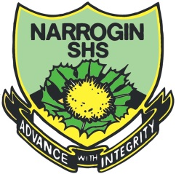

**Student Reflection – Australia’s International Trade [8 marks]**

Please respond to the following four questions – *be specific*:

I learned …

|  |
| --- |
|  |
|  |
|  |
|  |
|  |

I was surprised …

|  |
| --- |
|  |
|  |
|  |
|  |
|  |

I discovered …

|  |
| --- |
|  |
|  |
|  |
|  |
|  |

I wonder …

|  |
| --- |
|  |
|  |
|  |
|  |
|  |